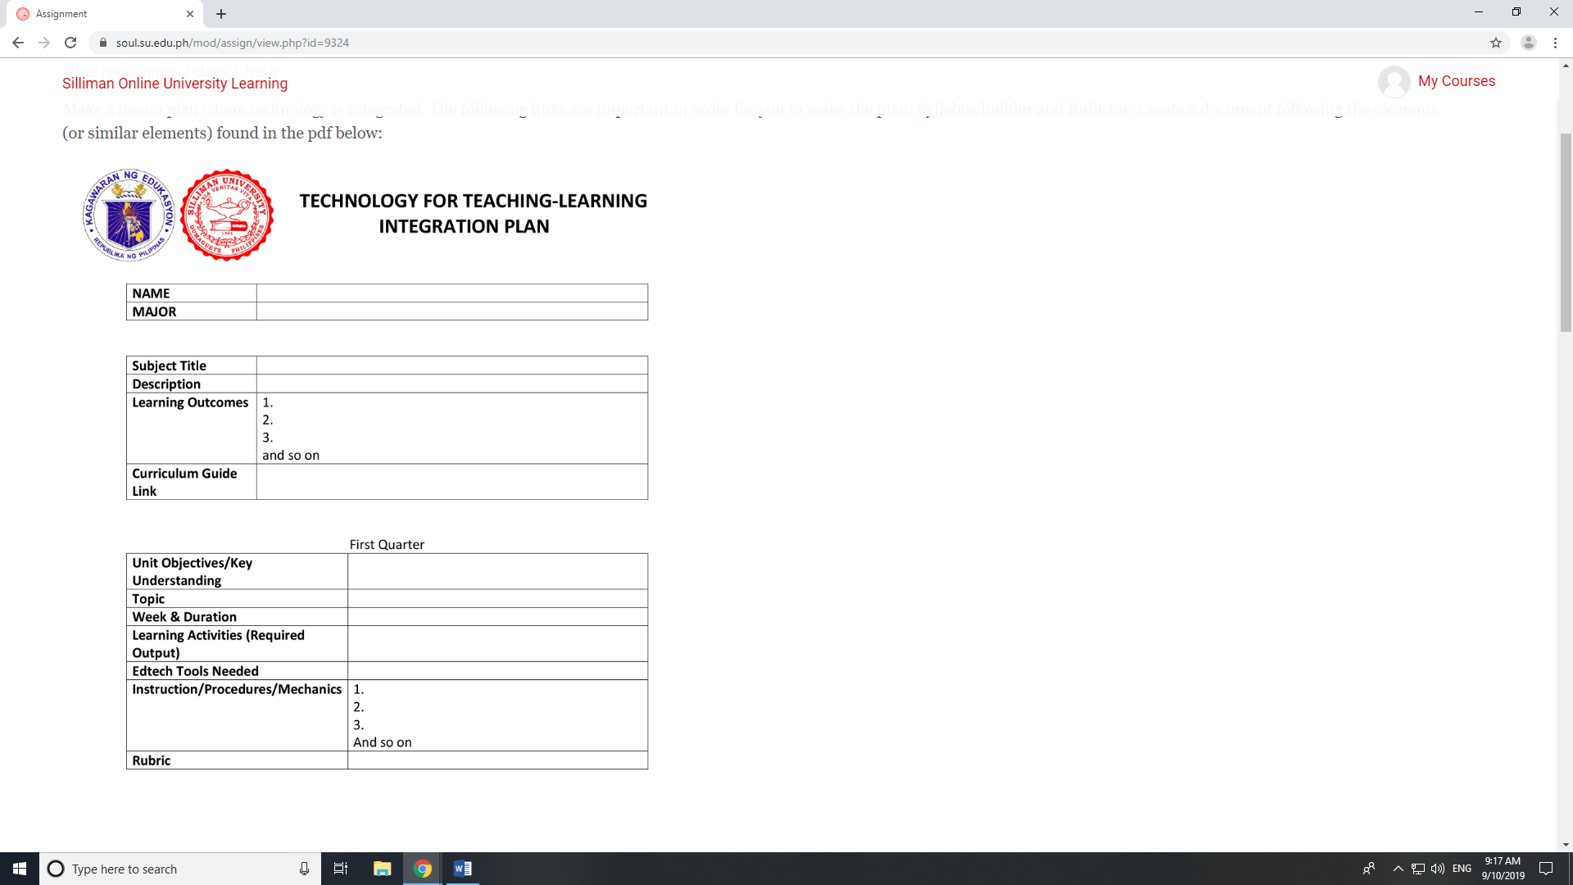
NAME | Hope B. Villar
MAJOR | Bachelor of Physical Education

Subject Title | Physical Education: Involving students into different Sports
Learning Competencies | - conducts physical activity and physical fitness assessments of family/school peers  - identifies training guidelines and FITT principles  - recognizes barriers (low level of fitness, lack of skill and time) to exercise  - prepares a physical activity program  - describes the nature and background of the sport  - executes the skills involved in the sport
Description | Physical education enhances body health, quality life and a sense of wellbeing. In school’s physical education and sports provide a venue for learners to be active and learn necessary skills, knowledge and attitude that leads to physically active lifestyles.
Learning Outcomes | At the end of the School Year:  - Students will know different Sports games  - Students will learn how to play different Sports  - Volleyball  - Basketball  - Students can be able to reflect and apply what they’ve learned in their daily social interactions.
Curriculum Guide Link | https://www.deped.gov.ph/wp-content/uploads/2019/01/PE-CG.pdf

First Quarter
Unit Objectives/Key Understanding | 1. identify the five volleyball skills by name  2. demonstrate understanding of mechanics of volleyball  3. summarize sequence of movement needed for five skills
Topic | Basic skills in Volleyball
Week & Duration | Weeks 1-2
Learning Activities (Required Output) | - Students will first execute the different exercises before playing the game.  - Students will be divided into 5 groups and each group will be given specific skills to be discussed.  - Put posters or a short video around the gym that portrays the specific skill and students will practice each skill as follows:  - The following posters will be discussed by the different assigned groups.  - Serve Station - Use wall space. Tape a target height and distance for students to practice serve.  - Block Station - Use the left side of net, both courts. Students will work in partner pairs on either side of the net. They will jump with arms raised, clap hands over the net, then repeat.  - Forearm Pass Station - Any open space. Students will work in partner pairs to toss the ball and return with the forearm pass, taking turns.  - Overhand Pass Station - Any open space. Students will work in partner pairs to toss the ball and return with the overhand pass, taking turns.  - Spike Station - Right side of net, both courts. Students will work with a partner who tosses the ball so they can practice the spike. Take turns.  - Walk students through each station, then divide them up and allow to practice. Show them the 'move' signal and make sure everyone understands expectations.  - Circulate and help students where necessary. Blow the whistle to signal moving to a new station.  - After they have learned the different skills, they will then be divided into 2 groups. They will be having an actual game by applying those skills that they have learned.  - The group should practice teamwork and collaboration with each other in order to win the game.  - After the game, students will give their insights and learning through an essay and let them express as well the importance of playing volleyball and making your body physically fit.
Edtech Tools Needed | Laptop for short video presentation and projector to project wider screen.
Instruction/Procedures/Mechanics | - In the actual game they will be divided into 2 groups.  - Each group should have first 6 players in order to play the first set.  - After the first set another set of people will follow for the second set  - In playing the game, make sure to use the different skills that you’ve learned.  - They will be criticized and graded according to the rubrics.
Rubrics

 |  | Basic Volleyball Skills
Score (1-4) | Skill Performed |  | Novice (1) | Learner (2) | Average (3) | Perfect (4)
 | Forearm Pass |  | Hands apart while passing, little weight shift, no control over ball and its path. 1-2 to target. | Elbows and knees locked, weight on heels of feet, hands in incorrect form, ball not to target. 3-5 to target. | Knees bent, athletic stance, hands properly together, arms extended, control of ball. 5-7 to target. | Knees bent, athletic stance, hands properly together, arms extended, on balls of feet control of ball, pass to target. 8-10 to target.
 | Setting |  | Feet not shoulder width apart, ball not controlled, considered a lift. 1-2 to target. | Sets ball above head, bends knees, feet shoulder width apart, hands in triangle form, ball goes to target. 3-5 to target. | Sets ball above head, knees, and elbows bent and fully extended when contacted with ball, shoulders face target, ball goes to target. 5-7 to target. | Sets ball above head, knees, and elbows bent and fully extended when contacted with ball, uses finger pads to contact ball, shoulders face target, ball to target. 8-10 to target.
 | Hitting |  | Incorrect approach overall, 1 to 2 successful hits out of 10 over and in the court. | Okay approach, incorrect footwork, elbow below head- 3 to 5 successful hits out of 10 over and in the court. | Correct approach, left right left footwork, elbow above head, follow through - 5 to 7 successful hits out of 10 over and in the court. | Correct approach, left right left footwork, elbow above head, follow through 8 to 10 successful hits out of 10 over and in the court.
 | Serving |  | Ball not over or near net, ball hit off fingers or wrist. 1-2 to target. | Serve made over net, not correct weight transfer. 3-5 to target. | Serve over and in, serve included weight transfer and correct contact. 5-7 to target. | Serve over and in, serve included weight transfer and correct contact, ball intricate to pass. 8-10 to target.
 | Communication |  | No communication runs into teammates. | Listens to teammates but does not call for balls. | Calls for most balls, listens for teammates, encourages interaction. | Calls for all balls, listens to teammates when they call balls, talks throughout entire play.
 | Teamwork |  | Rude to teammates, puts others down. | Puts self-down when making mistakes (shuts down) | Cheers on teammates while staying optimistic. | Includes everyone in game, support teammates.
 | Sportsmanship |  | Not honest, argues with teammates and opponents. | Dishonest, puts teammates and opponents down, pessimistic towards game. | Honest play helps teammates with skills and play, polite towards opponents. | Follows all rules, takes charge with bettering team and opponents’ skill and knowledge wise with a good attitude.

Second Quarter
Unit Objectives/Key Understanding | - Discuss the basic basketball skills.  - Execute the different skills in playing basketball.  - Apply what they have learned about the basic skills in basketball in their different social interactions towards the community.
Topic | Basic skills in Basketball
Week & Duration | Weeks 1-2
Learning Activities (Required Output) | - Students will be introduced first about the different drills and exercises before playing basketball.  - Students will also identify the different effects if exercises were not applied before playing the game.  - The class will be having a group activity  - The Group 1 will identify all the basic skills in playing basketball and give the meaning and explain. Present in class.  - The Group 2 to will make a yell about the basic basketball skills. Present in class.  - The Group 3 will identify which basic basketball skills are shown in the picture. Present in class.  - Students will perform the Basic Skills in playing Basketball  - After they have learned the different basic skills in basketball, students will have a short sharing about their journey towards learning the different skills in basketball.
Edtech Tools Needed | - Laptop and Projector for group Presentations  - Mobile applications for easy access and serve as their guide about the topic.
Instruction/Procedures/Mechanics | - The class will be divided into to 3 groups.  - Each group will be given specific task that will also give them idea about the topic.  - After they have learned the different skills, they will then be asked to perform 2 basic skills in playing basketball. Their performance will be graded based on the criteria or rubrics.
Rubrics

 |  | Basic Basketball Skills
Score (1-3) | Skill Performed |  | Needs improvement  1pt | Fair  2pts | Good  3pts
 | Dribbling |  | -Student cannot dribble the basketball with control while moving  -Dribbles with palm of hand  -Rigid stance, knees not bent. | -Student can dribble the basketball while moving  -Does not have good control  -Cannot dribble with head up  -Sometimes dribbles with finger pads | -Student can dribble the basketball with good control and proper positioning  -Student dribbles with head up  -Student dribbles with finger pads, knees bent  -Able to pivot while dribbling
 | Shooting |  | -Student cannot shoot the ball successfully.  -Student does not follow through.  -Student uses two hands to shoot | Student can sometimes shoot the ball successfully.  -Student sometimes follows through.  -Student uses two hands instead of one to shoot. | Student shoots the ball correctly.  -Student follows through.  -Student is usually successful in shooting.
 | Passing |  | -Student cannot pass the ball successfully  -student does not follow through on pass  -student cannot get the pass to teammates  -student does not make sure the pass recipient is ready for the ball | -Student can sometimes pass the ball successfully  -Student sometimes follows through the pass  -Student sometimes make sure the pass recipient is ready for the ball | Student passes the ball correctly  -Student follows through on pass  -Student usually completes the pass to a teammate  Student usually makes sure their teammate is ready for the pass
 | Lay-ups |  | -Student cannot demonstrate a proper lay-up.  -Has difficulty performing the proper 2 step approach after many attempts.  -Loses control of the ball. | -Student can sometimes demonstrate proper lay-ups.  -Can occasionally perform proper 2 step approach.  -Scoring lay-ups is inconsistent. | -Student demonstrates proper lay-ups  -Student uses correct 2 step approach.  -Student usually finds success in scoring lay-ups
 | Game Play |  | Student does not follow the rules of basketball.  -Student argues with other players.  -Student has little understanding of positioning and game play  -Student often is not involved in the play | Student sometimes follows the rules of basketball.  -Student does not always show proper defensive or offensive skills  -Student is sometimes not involved in the play | Student consistently follows the rules of basketball.  -Student is a team player.  -Student has good understanding of offensive and defensive play  -student is always involved in the game.

